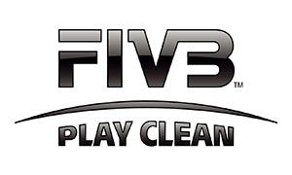


LOGIN

Play Clean is an online educational programme for athletes and support personnel, covering the new World Anti Doping Code. Here you will learn the basics of the code through 7 short modules of 3-4 minutes each. You don’t have to do the whole program in one go. Summaries will be sent to your registered e-mail address. When you have completed all modules, this will be registered and you will receive a certificate.

FIVB Players - in order for your Anti-Doping Education Certificate to be valid for a FIVB competition, you must click on the FIVB registered user and provide your FIVB number. All other Certificates will not be valid.
FIVB registered user
Home | Forgot password? | Create account

